JOURNAL OF CLINICAL MICROBIOLOGY, Sept. 2004, p. 3925–3931 Vol. 42, No. 9 0095-1137/04/$08.00+0 DOI: 10.1128/JCM.42.9.3925–3931.2004

Copyright © 2004, American Society for Microbiology. All Rights Reserved.

*rpoB* Gene Sequencing for Identification of *Corynebacterium* Species

Atieh Khamis, Didier Raoult, and Bernard La Scola*

*Unit´e des Rickettsies, CNRS UMR 6020, IFR 48, Facult´e de M´edecine, Universit´e de la M´editerrann´ee, Marseille, France*

Received 5 December 2003/Returned for modification 12 January 2004/Accepted 20 January 2004

**The genus *Corynebacterium* is a heterogeneous group of species comprising human and animal pathogens and environmental bacteria. It is defined on the basis of several phenotypic characters and the results of DNA-DNA relatedness and, more recently, 16S rRNA gene sequencing. However, the 16S rRNA gene is not polymorphic enough to ensure reliable phylogenetic studies and needs to be completely sequenced for accurate identification. The almost complete *rpoB* sequences of 56 *Corynebacterium* species were determined by both PCR and genome walking methods. In all cases the percent similarities between different species were lower than those observed by 16S rRNA gene sequencing, even for those species with degrees of high similarity. Several clusters supported by high bootstrap values were identified. In order to propose a method for strain identification which does not require sequencing of the complete *rpoB* sequence (approximately 3,500 bp), we identified an area with a high degree of polymorphism, bordered by conserved sequences that can be used as universal primers for PCR amplification and sequencing. The sequence of this fragment (434 to 452 bp) allows accurate species identification and may be used in the future for routine sequence-based identification of *Corynebacterium* species.**

The genus *Corynebacterium* is one of the largest genera in the coryneform group of bacteria (which consist of irregular gram-positive rods and aerobically growing, asporogenous, non-partially acid-fast bacteria). Originally, the genus *Coryne- bacterium* was created essentially to accommodate the diph- theria bacillus and some other species pathogenic for animals. *Bergey’s Manual of Systematic Bacteriology* listed only 17 *Cory- nebacterium* species; however, 11 new species were defined between 1987 and 1995 (6), and another 32 new species were

described between 1996 and 2003. From 2001 to 2003, up to 13 new species were validly published [(http://www.bacterio.cict.fr](http://www.bacterio.cict.fr/)

/c/corynebacterium.html). At present, the genus *Corynebacte- rium* contains more than 60 species, the vast majority of which have been isolated from human or animal samples. Chemot- axonomically, this genus includes species that possess wall che- motype IV (arabinose, galactose and *meso*-diaminopimelic acid), short-chain mycolic acids (approximately 22 to 36 carbon atoms), and DNA G+C contents ranging from 51 to 63 mol% (5, 6). The narrower definition of the genus *Corynebacterium* has resulted in the transfer of several species (*Clavibacter*, *Rhodococcus*, and *Turicella*) to other genera. However, there is still some evidence of heterogeneity within the genus *Coryne- bacterium*. For example, *Corynebacterium amycolatum* and *Corynebacterium kroppenstedtii* lack mycolic acids (1, 2), *Cory- nebacterium afermentans* and *Corynebacterium auris* exhibit G+C contents of more than 65 mol% (6). The use of molecu- lar genetic methods such as 16S rRNA gene (rDNA) sequence analysis has facilitated a much tighter circumscription of the genus, and the availability of comparative 16S rRNA gene sequence data with improved phenotypic data has resulted in much improved and more reliable species identification (14,

* Corresponding author. Mailing address: Unit´e des Rickettsies, CNRS UMR 6020, IFR 48, Facult´e de M´edecine, Universit´e de la M´editerrann´ee, 27 Boulevard Jean Moulin, 13385 Marseille Cedex 05, France. Phone: 33.04.91.38.55.17. Fax: 33.04.91.83.03.90. E-mail:

[bernard.lascola@medecine.univ-mrs.fr.](mailto:bernard.lascola@medecine.univ-mrs.fr)

16). These improvements in taxonomy and means of detection, together with an increased interest in *Corynebacterium* as an opportunistic infectious agent in humans, have resulted in the delineation of a plethora of new *Corynebacterium* species from human sources in recent years (6, 8). However, the identifica- tion of *Corynebacterium* species is difficult because it often requires fastidious procedures, such as chromatography, or a high number of tests that are not available with commercial identification systems (5). The sequence of the 16S rRNA gene is the most widely used molecular marker to determine the phylogenetic relationships of bacteria. However, low intrage- nus polymorphism limits its usefulness for taxonomic analysis or identification to the species level. As an example, the species *Corynebacterium pseudodiphtheriticum* and *Corynebacterium propinquum* and the species *Corynebacterium minutissimum* and *Corynebacterium aurimucosum* have high 16S rDNA sim- ilarity values (99.3 and 98.7%, respectively). Moreover, from the perspective of automated systems for gene sequence based- identification, this low degree of polymorphism obligates se- quencing of the complete 16S rRNA gene (approximately 1,500 bp) for accurate identification. Variable areas are spot- ted along the gene at positions 0 to 150, 300 to 400, 650 to

800, 850 to 950, and 1100 to 1250 (a total of 650 bp), with maximal variability ranging from 8 to 19% according to the region (Fig. 1).

Among the universal genes that can be used for taxonomic analysis and gene sequence-based identification, the RNA poly- merase beta subunit-encoding gene (*rpoB*) was used to study several unrelated genera, including *Bartonella* spp. (15), *Staph- ylococcus* spp. (3), members of the family *Enterobacteriaceae* (13), *Bosea* spp. and *Afipia* spp. (9), *Mycobacterium* spp. (10), and *Legionella* spp. (11). In the study described here, we in- vestigated the usefulness of *rpoB* sequencing for the differen- tiation and identification of 56 *Corynebacterium* species and 2 related species, *Rhodococcus equi* and *Turicella otitidis*. As *rpoB* is a large gene (approximately 3,500 bp), we also deter-

Downloaded from <http://jcm.asm.org/>on October 9, 2020 at TEXAS A & M UNIVERSITY

3925

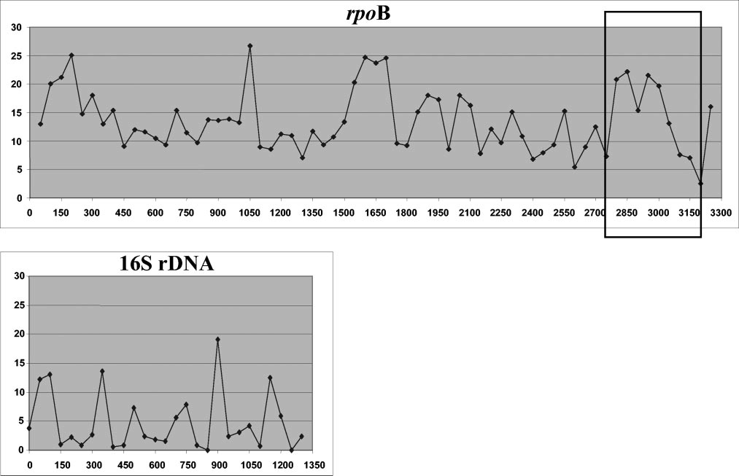

FIG. 1. Graphical representation of RSVs (*y* axis) in the *rpoB* and 16S rRNA gene sequences of *Corynebacterium* species studied by the use of windows of 50 nucleotides (the *x* axis indicates the nucleotide position). The hypervariable region bordered by conserved regions used for species identification with primers C2700F and C3130R is framed.

mined regions of variability in the sequence bordered by con- served sequences with the objective of designing universal prim- ers for amplification of a small but discriminative sequence for use in the routine identification of *Corynebacterium* species.

Downloaded from <http://jcm.asm.org/>on October 9, 2020 at TEXAS A & M UNIVERSITY

**MATERIALS AND METHODS**

**Bacterial strains.** The bacterial stains used in this study are listed in Table 1. Most strains were obtained from the Collection de l’Institut Pasteur (CIP) and from the Culture Collection of the University of Go¨teborg, Go¨teborg, Sweden (CCUG). All strains were cultured on Columbia agar plates with 5% sheep blood (Trypticase soy agar; bioM´erieux, Marcy-l’Etoile, France) and were incubated for 24 to 72 h at 30 to 37°C in a 5% CO2 atmosphere.

***rpoB* gene amplification and sequencing.** The sequence of the *rpoB* gene from *Corynebacterium* species and species most closely related to *Corynebacterium* species were aligned in order to produce a consensus sequence. The bacteria chosen were *Corynebacterium glutamicum*, *Amycolatopsis mediterranei*, and *My- cobacterium smegmatis* (GenBank accession numbers NC_003450, AF242549, and MSU24494, respectively). The consensus sequence was used to generate primers that were used in PCRs, for genome walking (17), and for sequencing. Additional primers were selected from ongoing base sequence determinations. All primers used in this study are summarized in Table 2.

Bacterial DNA was extracted from a heavy suspension of strains by using the QIAamp blood kit (Qiagen, Hilden, Germany), according to the recommenda- tions of the manufacturer. All PCR mixtures contained 2.5 X 10-2 U of *Taq* polymerase per µl; 1X *Taq* buffer; 1.8 mM MgCl2 (Gibco BRL, Life Technolo- gies, Cergy Pontoise, France); dATP, dCTP, dTTP, and dGTP (Boehringer Mannheim GmbH, Hilden, Germany) at concentrations of 200 µM each; and each primer (Eurogentec, Seraing, Belgium) at a concentration of 0.2 µM. The PCR mixtures were subjected to 35 cycles of denaturation at 94°C for 30 s, primer annealing for 30 s, and extension at 72°C for 2 min. Every amplification program began with a denaturation step of 95°C for 2 min and ended with a final elongation step of 72°C for 10 min. Determination of the complete sequences of the *rpoB* sequence ends was achieved by use of the sequences of both the 3 and the 5 ends of the gene and amplification by PCR with the Universal Genome- Walker kit (Clontech Laboratories, Palo Alto, Calif.). Briefly, genomic DNA was

digested with EcoRV, DraI, PvuII, StuI, and ScaI. The DNA fragments were then ligated with a GenomeWalker adaptor, which had one blunt end and one end with a 5 overhang. The ligation mixture with the adaptor and the genomic DNA fragments were used as templates for the PCR. This PCR was performed by use of an adaptor primer supplied by the manufacturer and specific primers to walk through the DNA sequence downstream. For the amplification, 1.5 U of Elongase (Boehringer Mannheim) was used with 10 pmol of each primer, each deoxynucleoside triphosphate at a concentration of 20 mM, 10 mM Tris-HCl, 50 mM KCl, 1.6 mM MgCl2, and 5 µl of template with a final volume of 50 µl. Amplicons were purified for sequencing by use of a QIAquick spin PCR purification kit (Qiagen) by the protocol of the supplier. Sequencing reactions were carried out with the reagents of the ABI Prism 3100 DNA sequencer (dRhod.Terminator RR Mix; Perkin-Elmer Applied Biosystems) by the standard automated sequencer protocol.

**Determination of discriminative partial sequences in 16S rRNA and *rpoB* genes.** In order to search for parts of sequences with high degrees of variabil- ity bordered by conserved regions, we used SVARAP software (Sequence Vari- ability Analysis Program [[http://ifr48.free.fr/recherche/jeu_cadre/jeu_rickettsie](http://ifr48.free.fr/recherche/jeu_cadre/jeu_rickettsie)

.html]) (9). After this analysis was done, the most polymorphic areas in *rpoB* were identified, and primers designed to be specific for the border conserved region were used for PCR amplification of this region. The PCR conditions that incor- porated this consensus primer pair (C2700F-C3130R; Table 2) were the same as those described above. These primers were then used for amplification and sequencing of the hypervariable region for all the strains studied in this work.

|  |  |
| --- | --- |
|  | ***rpoB* sequence analysis.** The nucleotide sequences of the *rpoB* gene fragments |
| obtained were processed into sequence data with Sequence Analysis Software | |
| (Applied Biosystems), and partial sequences were combined into a single con- | |
| sensus sequence with Sequence Assembler Software (Applied Biosystems). All | |
| GenBank accession numbers are listed in Table 1. Multiple-sequence alignments | |
| and percent similarities of the *rpoB* and 16S rRNA genes between the different | |
| species were obtained with the CLUSTAL W program (18) on the EMBL-EBI | |
| web server [(http://www.ebi.ac.uk/clustalw/).](http://www.ebi.ac.uk/clustalw/)) Phylogenetic trees were obtained | |
| from DNA sequences by three different methods: the neighbor-joining, maxi- | |
| mum-parsimony, and maximum-likelihood methods (4). Bootstrap replicates | |
| were performed in order to estimate the reliabilities of the nodes of the phylo- | |

TABLE 1. Species for which *rpoB* sequences were determined, including GenBank access numbers and sizes of the sequences determined

Genbank accession no. Size (bp) of *rpoB*

Species Strain

sequence determined

16S rRNA gene *rpoB* gene Complete Partial

*Corynebacterium accolens* CIP 104783T AJ439346 AY492242 3,282 446

*Corynebacterium afermentans* subsp. *afermentans* CIP 103499T X82054 AY492265 3,347 446

*Corynebacterium afermentans* subsp. *lipophilum* CIP 103500T X82055 AY492266 3,178 446

*Corynebacterium ammoniagenes* CIP 101283T X82056 AY492243 3,349 446

*Corynebacterium amycolatum*

CIP 103452T X82057 AY492241 3,435 434

*Corynebacterium argentoratense* CIP 104296T X83955 AY492249 3,349 446

*Corynebacterium aurimucosum* CCUG 47449T AJ309207 AY492282 3,330 446

*Corynebacterium auris* CIP 104632T X81873 AY492234 3,357 446

*Corynebacterium auriscanis* CIP 106629T AJ243820 AY492244 3,346 452

*Corynebacterium bovis* CIP 5480T X82051 AY492236 3,450 452

*Corynebacterium callunae* CIP 104277T X82053 AY492245 3,340 446

*Corynebacterium camporealensis* CIP 105508T Y09569 AY492246 3,340 446

*Corynebacterium capitovis* CIP 106739T AJ297402 AY492247 3,350 446

*Corynebacterium confusum* CIP 105403T Y15886 AY492248 3,356 446

*Corynebacterium coyleae* CIP 104919T X96497 AY492250 3,314 446

*Corynebacterium cystitidis* CIP 103424T X82058 AY492251 3,340 446

*Corynebacterium diphtheriae* CIP 100721T X82059 AY492230 3,477 446

*Corynebacterium durum* CIP 105490T Z97069 AY492252 3,340 446

*Corynebacterium efficiens* YS-314 AB055963 AP005215 3,480 446

*Corynebacterium falsenii* CIP 105466T Y13024 AY492253 3,330 452

*Corynebacterium felinum* CIP 106740T AJ401282 AY492254 3,334 446

*Corynebacterium flavescens* CIP 69.5T X82060 AY492255 3,303 446

*Corynebacterium freneyi* CIP 106767T AJ292762 AY492237 3,345 434

*Corynebacterium glucuronolyticum* CIP 104577T X86688 AY492256 3,328 434

*Corynebacterium glutamicum* ATCC 13032 X80629 NC_003450 3,480 446

*Corynebacterium imitans* CIP 105130T Y09044 AY492259 3,333 446

*Corynebacterium jeikeium* CIP 103337T X82062 AY492231 3,463 452

*Corynebacterium kroppenstedtii* CIP 105744T Y10077 AY492274 3,349 452

*Corynebacterium kutscheri* CIP 103423T X82063 AY492257 3,168 446

*Corynebacterium lipophiloflavum* CIP 105127T Y09045 AY492260 3,340 446

*Corynebacterium macginleyi* CIP 104099T X80499 AY492276 3,173 446

*Corynebacterium mastitidis* CIP 105509T Y09806 AY492281 3,174 446

*Corynebacterium matruchotii* CIP 81.82T X82065 AY492238 3,338 446

*Corynebacterium minutissimum* CIP 100652T X84679 AY492235 3,358 446

*Corynebacterium mucifaciens* CIP 105129T Y11200 AY492261 3,330 446

*Corynebacterium mycetoides* CIP 55.51T X82066 AY492262 3,332 446

*Corynebacterium phocae* CIP 105741T Y10076 AY492277 3,180 446

*Corynebacterium pilosum* CIP 103422T X84246 AY492258 3,296 446

*Corynebacterium propinquum* CIP 103792T X81917 AY492279 3,179 446

*Corynebacterium pseudodiphtheriticum* CIP 103420T X81918 AY492232 3,477 446

*Corynebacterium pseudotuberculosis* CIP 102968T X81916 AY492239 3,447 446

*Corynebacterium renale* CIP 103421T X81909 AY492240 3,442 446

*Corynebacterium riegelii* CIP 105310T Y14651 AY492278 3,180 446

*Corynebacterium seminale* CIP 104297T X84375 AY492263 3,153 434

*Corynebacterium simulans* CIP 106488T AJ012837 AY492264 3,176 446

*Corynebacterium singulare* CIP 105491T Y10999 AY492280 3,180 446

*Corynebacterium spheniscorum* CCUG 45512T AJ429234 AY492283 3,283 446

*Corynebacterium striatum* CIP 81.15T X81910 AY492267 3,346 446

*Corynebacterium sundsvallense* CIP 105936T Y09655 AY492268 3,359 446

*Corynebacterium terpenotabidum* CIP 105927T AB004730 AY492269 3,286 452

*Corynebacterium testudinoris* CCUG 41823T AJ295841 AY492284 3,320 446

*Corynebacterium thomssenii* CIP 105597T AF010474 AY492270 3,352 446

*Corynebacterium ulcerans* CIP 106504T X81911 AY492271 3,176 446

*Corynebacterium urealyticum* CIP 103524T X81913 AY492275 3,172 452

*Corynebacterium variabile* CIP 102112T AJ222815 AY492272 3,343 452

*Corynebacterium vitaeruminis* CIP 827T X84680 AY492273 3,296 446

*Corynebacterium xerosis* CIP 100653T X81914 AY492233 3,447 434

*Turicella otitidis* CIP 104075T X73976 AY492287 3,250 446

*Rhodococcus equi* (formerly *Corynebacterium hoagii*) CIP 81.17T X82052 AY492285 3,357 449

*Rhodococcus equi* CIP 5472T AF490539 AY492286 3320 449

Downloaded from <http://jcm.asm.org/>on October 9, 2020 at TEXAS A & M UNIVERSITY

ated randomly with the SEQBOOT program in the PHYLIP software package.

genetic trees obtained. Bootstrap values were obtained from 1,000 trees gener-

**RESULTS**

***rpoB* sequences of *Corynebacterium* species.** Almost com- plete *rpoB* gene sequences were determined for all strains. The

*rpoB* sequence was more polymorphic than the 16S rDNA sequence. This higher degree of polymorphism was particularly evident for species not well differentiated by 16S rDNA se- quence analysis (Table 3), as among the 11 pairs of species with 16S rRNA gene similarities ranging from 98.5 to 99.7%, the similarities of the *rpoB* gene ranged from 84.9 to 96.6%. The

TABLE 2. Primers used for amplification and sequencing of the *rpoB* gene in this study

**Phylogenetic analysis.** On the basis of *rpoB* gene sequence analysis, phylogenetic analysis by the neighbor-joining, maxi-

Primer name

Primer sequence (5 –3 ) Position

*a Tmb*

(°C)

mum-parsimony, and maximum-likelihood methods provided similar and reliable organizations for the four clusters sup-

C240F GGAAGGAYGCATCTTGGCAGTCT -13 68

C150F GGYACGCCYGAGTGGC 133 56

C35F GGAAGGACCCATCTTGGCAGT -13 66

C41F CAGTCTCCCGCCAGACCA 5 60

C445R CATYGGGAARTCRCCGATGA 401 60

C40F CAGTCTCCCGCCAGACCAA 5 62

C390F ATCAAGTCYCAGACKGTYTTCATC 322 68

C390R GATGAARACMGTCTGRGACTTGAT 322 68

C630F GACCGCAAGCGYCGCCAG 621 64

C600f TGGYTBGARTTYGACGT 574 50

C600r ACGTCRAAYTCVARCCA 574 50

C640R GGCTGRCGRCGCTTGCGGT 623 66

C890F TACAAGRTCAACCGCAAG 883 52

C820R GGRCGYTGCTTGCGGTAGA 772 62

C1050F CGAYGACATYGACCACTT 1040 54

C1050R GGTTRCCRAAGTGGTCRATGTC 1045 68

C1295F CAGTTYMTGGACCAGAACAAC 1254 62

C1410F GAGCGYATGACCACBCAGGA 1144 64

C1410R TCCTGVGTGGTCATRCGCTC 1144 64

C1415F CBCACTACGGMCGYATGTG 1373 62

C1740F ACGATGCTAACCGTGCACTGAT 1739 66

C1740R CCCATCAGTGCACGGTTAGCAT 1742 68

C1765R GTGCTCSAGGAAYGGRATCA 1718 62

C1770F TGATGGGYGCSAACATGCAG 1757 64

C1800f ATGGGYGCSAACATGCAG 1759 56

C1800r CTGCATGTTSGCRCCCAT 1759 56

C2160R GRCCYTCCCAHGGCATGAA 2107 60

C2130F GGARGGCCACAACTACGAGGA 2118 64

C2130R GTGGCCYTCCCAHGGCATGAA 2107 68

C2350F ACATCCTGGTCGGTAAGGTCAC 2339 68

C2350R GTGACCTTACCGACCAGGATGT 2339 68

C2385F CATCCTSGTSGGYAAGGTCA 2340 64

C2410R ATGATCGCRTCCTCGTAGTTGTG 2125 68

C2410F CACAACTACGAGGAYGCGATCAT 2125 68

C2470R CGATCTCGTGCTCCTCGATGT 2192 66

C2590F CARAAGCGCAAGATCCARGA 2563 60

C2625F AGATCCARGAYGGCGAYAAG 2572 60

C3190F ATGGAGGTGTGGGCAATGCAG 3154 66

C3190R CTGCATTGCCCACACCTCCAT 3154 66

C3200r CTGCATBGCCCACACCTCCAT 3154 68

C3215R GCCTGCATBGCCCACACCT 3158 64

C3300F GAAGGGCGADAAYATYCCGGAT 3264 66

C3300R TCCGGRATRTTHTCGCCCTTCA 3263 66

ported by high bootstrap values (Fig. 2). On the contrary, only cluster 4 was evidenced when 16S rRNA gene sequence anal- ysis was used (Fig. 3). The bootstrap values at the nodes were in all cases higher than those observed by 16S rRNA gene sequencing. Values >95% were observed for 14 of 55 nodes for the 16S rRNA gene, whereas values >95% were observed for 24 of 55 nodes for the *rpoB* gene (*P* = 0.004 by the chi- square test). For some species, such as *Corynebacterium testu- dinoris*, *Corynebacterium renale*, *Corynebacterium seminale*, and *Corynebacterium glucuronolyticum*, the phylogenetic position was more difficult to assess. The position of *T. otitidis* in a genus separate from *Corynebacterium* is also questionable. Study of the *rpoB* gene confirms that the genus *Rhodococcus* is different from *Corynebacterium* and that *Corynebacterium hoa- gii* is not another species but is *R. equi* and that *C. seminale* and

*C. glucuronolyticum* are the same species (http://www.bacterio

.cict.fr/c/corynebacterium.html).

**Strain identification.** Four highly variable zones were deter- mined by the use of SVARAP software (Fig. 1). These zones were between positions 1 and 450, 800 and 1100, 1400 and 1750, and 2750 and 3200. Attempts to design universal primers that amplify hypervariable areas were unsuccessful for the first three regions.

this region was the most variable one (Fig. 1).

from 434 to 452 bp, depending on the species. Interestingly,

The amplified fragment was

gion in all *Corynebacterium* species,

C3130R) that allowed the successful amplification of the re-

We designed a consensus primer pair (C2700F-

*R. equi*, and *T. otitidis*

between positions 2750 and 3200.

The similarities observed in the partial *rpoB* sequence were also significantly

TABLE 3. Comparison of similarities of 16S rRNA and *rpoB* gene sequences between the two subspecies of *C. afermentans* and among the 11 pairs of closely related species, with

statistical comparison of mean similarities

C3350R CCTTGAASGACTCHGGRATAC 3290 64

C3490R CACGGGACAGGTTGATGCC 3430 62

C3630R GAGMACCTCSACGTTSAGGCACA 3335 70

C3500R TCGTCDCGBGACAGGTTGATG 3433 66

62

60

TCCATYTCRCCRAARCGCTG

CGWATGAACATYGGBCAGGT

C3130R

C2700F

2714

3140

*a* The position of a primer is relative to that of the *Corynebacterium diphtheriae rpoB* gene sequence (GenBank accession no. AY492230).

*b Tm*, melting temperature.

Species or subspecies compared

16S

% Similarity

*ropB* gene

|  |  |  |  |
| --- | --- | --- | --- |
|  | rDNA | Complete sequence*b* | Partial sequence*c* |
| Closely related species*a*  *C. diphtheriae-C. ulcerans* | 98.5 | 86 | 87.9 |
| *C. diphtheriae-C. pseudotuberculosis* | 98.5 | 84.9 | 87.9 |
| *C. ulcerans-C. pseudotuberculosis* | 99.7 | 93.6 | 93 |
| *C. pseudodiphtheriticum-C. propinquum* | 99.3 | 89.7 | 93.9 |
| *C. aurimucosum-C. singulare* | 99 | 94.2 | 93.9 |
| *C. aurimucosum-C. minutissimum* | 98.7 | 94.6 | 93.9 |
| *C. singulare-C. minutissimum* | 98.9 | 93.8 | 95.5 |
| *C. xerosis-C. freneyi* | 98.7 | 96.6 | 95.9 |
| *C. macginleyi-C. accolens* | 98.7 | 93.3 | 91.7 |
| *C. sundsvallens-C. thomssenii* | 98.9 | 90.4 | 91 |
| *C. mucifaciens-C. afermentans* | 98.5 | 94 | 92.4 |
| Mean | 98.85 | 91.91 | 92.45 |
| *C. afermentans* subsp. *afermentans-*  *C. afermentans* subsp. *lipophilum* | 99.8 | 98.2 | 96.6 |

means for the similarities between the 16S rRNA gene and *rpoB* gene sequences among these 11 pairs were statistically significant. This higher degree of polymorphism was also sig- nificant when it was calculated on the basis of range site vari- ability (RSV) (Fig. 1). RSVs of >10 were observed in the *rpoB* gene for 44 of 67 windows of 50 nucleotides (WOFN) and in the 16S rRNA gene for 5 of 27 WOFN (*P* 0.001 by the chi-square test). Likewise, RSVs of >20 were observed in the *rpoB* gene for 13 of 67 WOFN and in the 16S rRNA gene for 0 of 27 WOFN (*P* = 0.008 by Fisher’s exact test). The similarity between the two *C. afermentans* subspecies was 98.2% and, thus, was 1.6% above the highest level of similarity between two species.

Downloaded from <http://jcm.asm.org/>on October 9, 2020 at TEXAS A & M UNIVERSITY

*a* Determined on the basis of >98.5% similarity of the 16S rRNA gene se- quence.

*b P* = 0.03 compared to the results for 16S rDNA (Student’s *t* test).

*c P* = 0.01 compared to the results for 16S rDNA (Student’s *t* test).

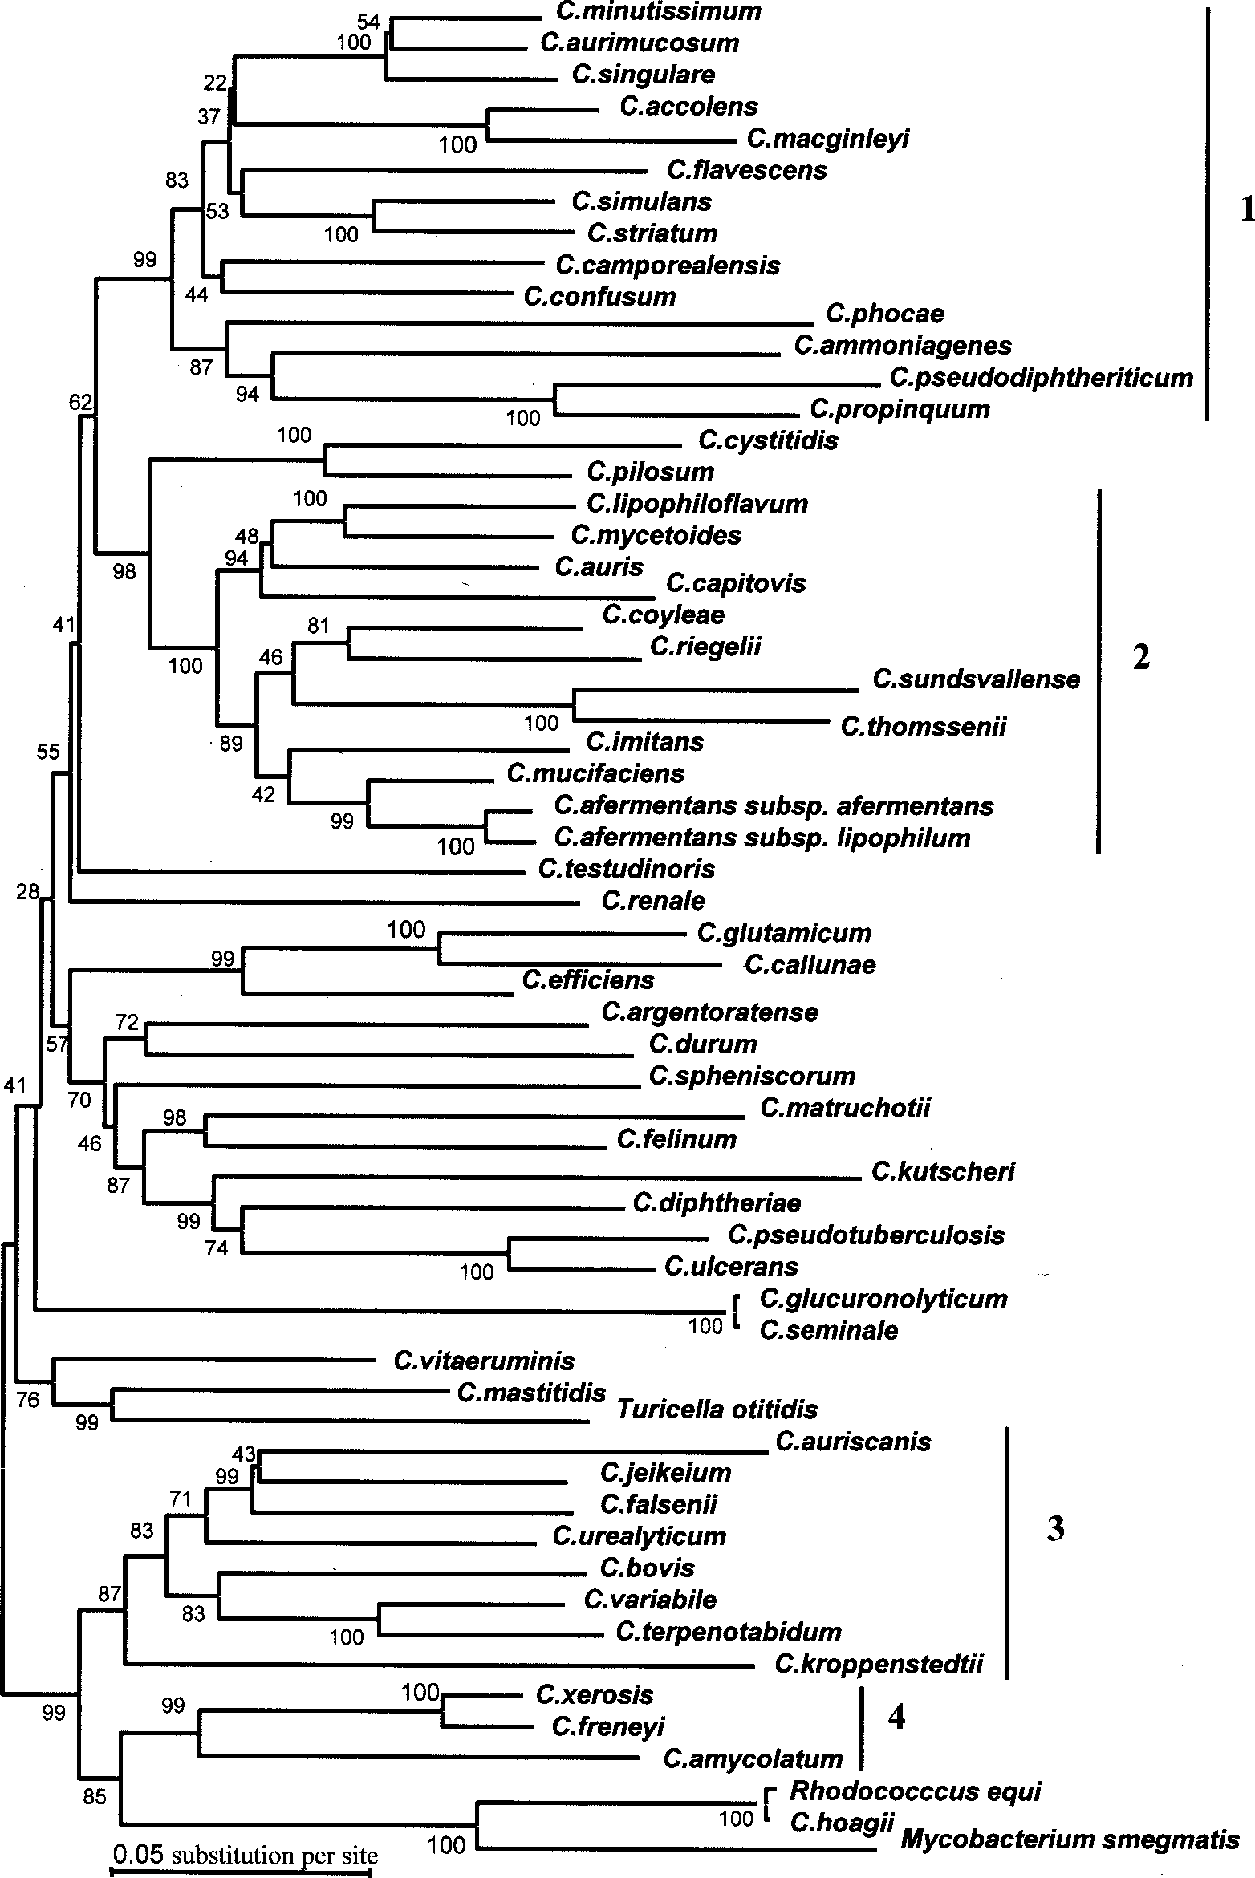

FIG. 2. Dendrogram representing the phylogenetic relationships of *Corynebacterium* species obtained by the neighbor-joining method. The tree was derived from the alignments of *rpoB* gene sequences. The support of each branch, as determined from 1,000 bootstrap samples, is indicated by the value at each node (in percent).

less than those observed in the 16S rRNA gene and ranged from 87.9 to 95.9% (Table 3). The similarity between the two

Downloaded from <http://jcm.asm.org/>on October 9, 2020 at TEXAS A & M UNIVERSITY

*C. afermentans* subspecies was 96.6% and was thus 0.7% great- er than the highest degree of similarity between two species.

**DISCUSSION**

The description of new bacterial species at present is based on the results of DNA-DNA hybridization and the description

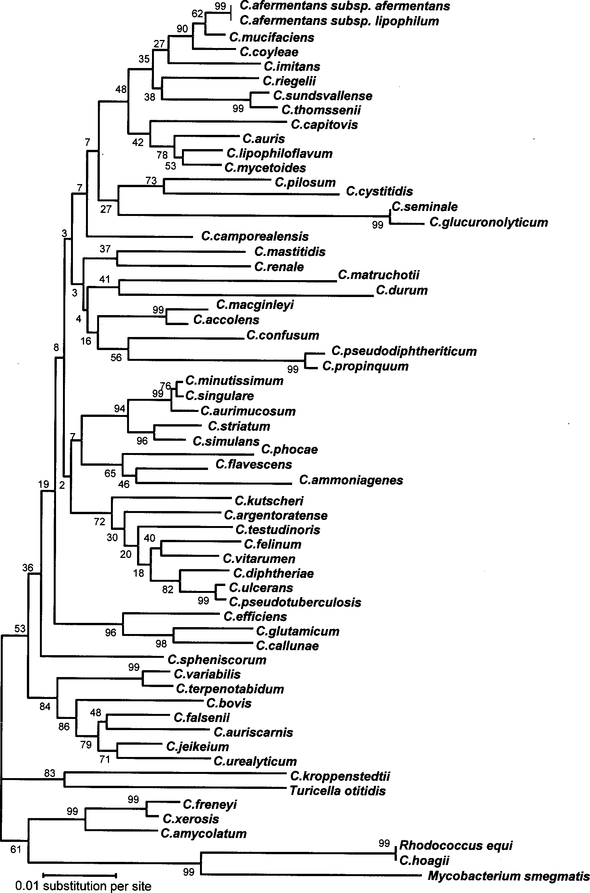

FIG. 3. Dendrogram representing the phylogenetic relationships of *Corynebacterium* species obtained by the neighbor-joining method. The tree was derived from alignment of 16S rRNA gene sequences. The support of each branch, as determined from 1,000 bootstrap samples, is indicated by the value at each node (in percent).

of phenotypic characteristics, so-called polyphasic classifica- tion data (7, 19). However, DNA-DNA hybridization is diffi- cult to perform, expensive, technically complex, and labor- intensive. The scarcity of reproducible and distinguishable

Downloaded from <http://jcm.asm.org/>on October 9, 2020 at TEXAS A & M UNIVERSITY

characters frequently limits phenotypic characterization and, thus, phenotype-based identification in routine clinical micro- biology laboratories. The development of gene amplification and sequencing, especially that of 16S rRNA gene sequences,

has simplified the taxonomy and identification of bacteria, par- ticularly those lacking distinguishable phenotypic characteris- tics. However, the 16S rDNA sequences of *Corynebacterium* spp. are not variable enough to ensure confident results from phylogenetic studies based on high bootstrap values (Fig. 3) or to allow determination of a short sequence for accurate iden- tification (Fig. 1).

polymorphic than the 16S rRNA gene,

these bacteria, confirm that this gene is significantly more

Our data, based on the *rpoB* sequences of

Downloaded from <http://jcm.asm.org/>on October 9, 2020 at TEXAS A & M UNIVERSITY

and we propose that it be used to replace or complement the 16S rRNA gene for phylogenetic studies of *Corynebacterium*. Deeply branching nodes were supported by high bootstrap values and allowed the identification of four clusters (Fig. 2). Even among species not resolved into clusters, some groups of bacteria were confi- dently identified, such as groups containing *Corynebacterium diphtheriae*, *Corynebacterium pseudotuberculosis*, *Corynebacte- rium ulcerans*, and *Corynebacterium kutscheri*.

The high similarity values for the 16S rRNA gene sequences observed among closely related *Corynebacterium* spp. indicate that the complete sequence should be determined for accurate sequence-based identification (Table 3).

partial sequence between two species was 95.9%,

all *Corynebacterium* spp. The highest degree of similarity of this

ment polymorphic enough to ensure accurate identification of

allow amplification and sequencing of a 434- to 452-bp frag-

software, we have designed universal primers for *rpoB* that

By using SVARAP

whereas it was 99.7% for the complete 16S rRNA gene (Table 3), a se- quence nearly four times longer. Moreover, the partial se- quences of the *rpoB* genes of two subspecies of *C. afermentans* had a similarity of 96.6%, which was thus 0.7% above the limit of similarity between two different species. This difference was only 0.1% for the complete 16S rRNA gene sequence, render- ing it impossible to distinguish a subspecies from a closely related species only on the basis of this sequence. This differ- ence was even higher (1.6%) when the complete *rpoB* se- quence was considered. From these data, the cutoff for the definition of species and subspecies in the genus *Corynebacte- rium* based on the complete *rpoB* sequence can be made on the basis of similarities of 96.6 and >98%, respectively. These cutoffs are in the same range as those observed for the genera *Bartonella*, *Afipia*, and *Bosea* (12, 9). However, the similarities of a large collection of different strains within particular spe- cies would have to be determined for validation of these cut- offs.

**ACKNOWLEDGMENT**

We are indebted to E. Falsen for providing some of the *Corynebac- terium* strains as a gift.

**REFERENCES**

1. **Collins, M. D., R. A. Burton, and D. Jones.** 1998. *Corynebacterium amyco- latum* sp. nov., a new mycolic acid-less *Corynebacterium* species from human skin. FEMS Microbiol. Lett. **49:**349–352.
2. **Collins, M. D., E. Falsen, E. Akervall, B. Sjo¨d´en, and N. Alvarez.** 1998. Characterization of a novel non-mycolic acid containing *Corynebacterium*: description of *Corynebacterium kroppenstedtii* sp. nov. Int. J. Syst. Bacteriol. **48:**1449–1454.
3. **Drancourt, M., and D. Raoult.** 2002. *rpoB* gene sequence-based identifica- tion of *Staphylococcus* species. J. Clin. Microbiol. **40:**1333–1338.
4. **Felsenstein, J.** 1989. PHYLIP—phylogeny inference package (version 3.2). Cladistics **5:**164–166.
5. **Funke, G., and K. A. Bernard.** 1999. Coryneform gram-positive rods, p. 319–345. *In* P. R. Murray, E. J. Baron, M. A. Pfaller, F. C. Tenover, and

R. H. Yolken (ed.), Manual of clinical microbiology, 7th ed. American Society for Microbiology, Washington D.C.

1. **Funke, G., A. von Graevenitz, J. E. Clarridge III, and K. A. Bernard.** 1997. Clinical microbiology of coryneform bacteria. Clin. Microbiol. Rev. **10:**125– 159.
2. **Grimont, P. A. D.** 1988. Use of DNA reassociation in bacterial classification. Can. J. Microbiol. **34:**541–546.
3. **Janda, W. M.** 1998. *Corynebacterium* species and the coryneform bacteria, part I: new and emerging species in the genus *Corynebacterium*. Clin. Mi- crobiol. Newsl. **20:**41–52.
4. **Khamis, A., P. Colson, D. Raoult, and B. La Scola.** 2003. Usefulness of *rpoB* gene sequencing for identification of *Afipia* and *Bosea* species, including a strategy for the choice of discriminative partial sequences. Appl. Environ. Microbiol. **69:**6740–6749.
5. **Kim, B. J., S. H. Lee, M. A. Lyu, S. J. Kim, G. H. Bai, G. T. Chae, E. C. Kim,**

**C. Y. Cha, and Y. H. Kook.** 1999. Identification of mycobacterial species by comparative sequence analysis of the RNA polymerase gene (*rpoB*). J. Clin. Microbiol. **37:**1714–1720.

1. **Ko, K. S., H. K. Lee, M. Y. Park, K. H. Lee, Y. J. Yun, S. Y. Woo, H. Miyamoto, and Y. H. Kook.** 2002. Application of RNA polymerase beta- subunit gene (*rpoB*) sequences for the molecular differentiation of *Legionella* species. J. Clin. Microbiol. **40:**2653–2658.
2. **La Scola, B., Z. Zeaiter, A. Khamis, and D. Raoult.** 2003. Gene sequence based criteria for species definition in bacteriology: the *Bartonella* paradigm. Trends Microbiol. **11:**318–321.
3. **Mollet, C., M. Drancourt, and D. Raoult.** 1997. *rpoB* sequence analysis as a novel basis for bacterial identification. Mol. Microbiol. **26:**1005–1011.
4. **Pascual, C., P. A. Lawson, J. A. E. Farrow, M. N. Gimenez, and M. D. Collins.** 1995. Phylogenetic analysis of the genus *Corynebacterium* based on the 16S rRNA gene sequences. Int. J. Syst. Bacteriol. **45:**724–728.
5. **Renesto, P., J. Gouvernet, M. Drancourt, V. Roux, and D. Raoult.** 2001. Use of *rpoB* gene analysis for detection and identification of *Bartonella* species.

J. Clin. Microbiol. **39:**430–437.

1. **Ruimy, R., P. Riegel, P. Boiron, H. Montiel, and R. Christen.** 1995. Phylog- eny of the genus *Corynebacterium* deduced from analyses of small-subunit ribosomal DNA sequences. Int. J. Syst. Bacteriol. **45:**740–746.
2. **Siebert, P. D., A. Chenchik, D. E. Kellogg, K. A. Lukyanov, and S. A. Lukyanov.** 1995. An improved PCR method for walking in uncloned geno- mic DNA. Nucleic Acids Res. **23:**1087–1088.
3. **Thompson, J. D., D. G. Higgins, and T. J. Gibson.** 1994. CLUSTAL W: improving the sensitivity of progressive multiple sequence alignment through sequence weighting, position-specific gap penalties and weight matrix choice. Nucleic Acids Res. **22:**4673–4680.
4. **Wayne, L. G., D. J. Brenner, R. R. Colwell, P. A. D. Grimont, O. Kandler,**

**M. L. Krichevsky, L. H. Moore, W. E. C. Moore, R. G. E. Murray, E. Stackebrandt, M. P. Starr, and H. G. Tru¨per.** 1987. Report of the Ad Hoc Committee on Reconciliation of Approaches to Bacterial Systematics. Int. J. Syst. Bacteriol. **37:**463–464.